**Digital Nurture 4.0 Java FSE**

**Week 7 ReactJS - HOL**

**Mandatory Exercise (HandsOn 10)**

**Exercise 10:** Create a React Application named “officespacerentalapp” which uses React JSX to create elements, attributes and renders DOM to display the page.

Create an element to display the heading of the page.

Attribute to display the image of the office space

Create an object of office to display the details like Name, Rent and Address.

Create a list of Object and loop through the office space item to display more data.

To apply Css, Display the color of the Rent in Red if it’s below 60000 and in Green if it’s above 60000.

**Output:**

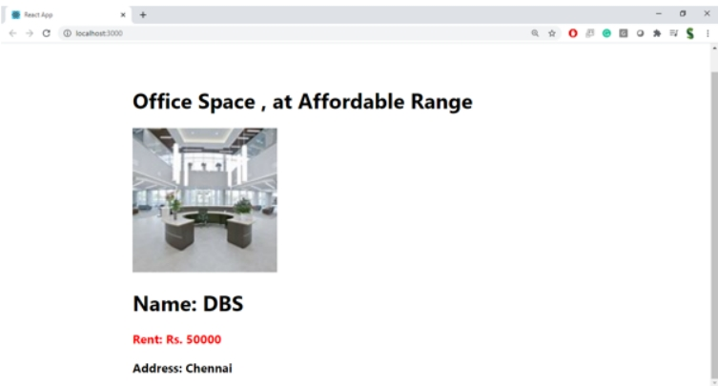

**Hint:**

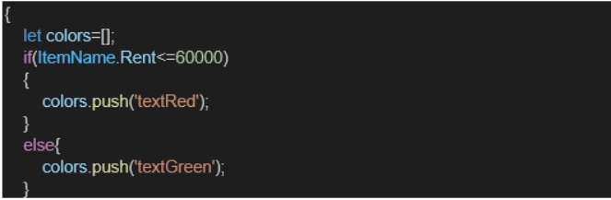

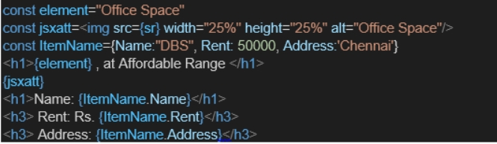

**Answer:**

**OfficeData.js:**

const officeData = [

{

name: "Redstone",

address: "Anna Salai, Chennai",

rent: 55000,

image: "/images/office1.jpg",

},

{

name: "WeWork",

address: "Indiranagar, Bangalore",

rent: 75000,

image: "/images/office2.jpg",

},

];

export default officeData;

**OfficeCard.js:**

import React from "react";

import "./OfficeCard.css";

function OfficeCard({ office }) {

const rentClass = office.rent < 60000 ? "low-rent" : "high-rent";

const borderClass = office.rent < 60000 ? "red-border" : "green-border";

return (

<div className="card">

<p><strong>Name:</strong> <span className={rentClass}>{office.name}</span></p>

<p><strong>Address:</strong> {office.address}</p>

<p><strong>Rent:</strong> <span className={rentClass}>₹{office.rent}</span></p>

<img src={office.image} alt={office.name} className={borderClass} />

</div>

);

}

export default OfficeCard;

**OfficeCard.css:**

.card {

margin: 20px;

padding: 20px;

border: 1px solid #ccc;

border-radius: 10px;

}

.low-rent {

color: red;

font-weight: bold;

}

.high-rent {

color: green;

font-weight: bold;

}

.red-border {

border: 2px solid red;

width: 300px;

height: auto;

border-radius: 5px;

}

.green-border {

border: 2px solid green;

width: 300px;

height: auto;

border-radius: 5px;

}

**App.js:**

import React from "react";

import officeData from "./officeData";

import OfficeCard from "./OfficeCard";

function App() {

return (

<div>

<h2 style={{ textAlign: "center", marginTop: "20px" }}>

Available Office Spaces for Rent

</h2>

{officeData.map((office, index) => (

<OfficeCard key={index} office={office} />

))}

</div>

);

}

export default App;

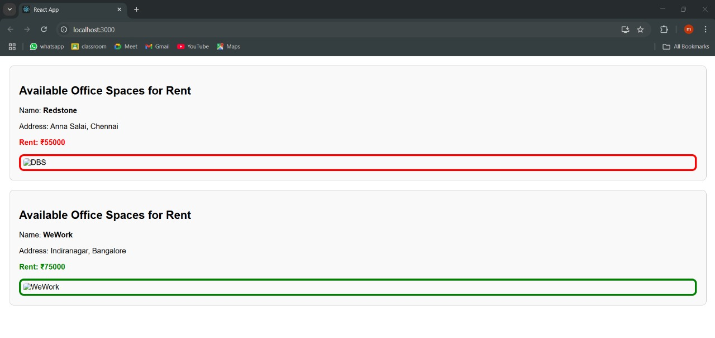**Output:**